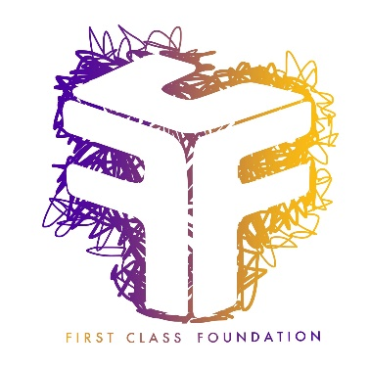

Photo Consent and Release Form

Without expectation of compensation or other remuneration, now or in the future, I hereby give my consent to First Class Foundation, its affiliates and agents, to use my image and likeness and/or any interview statements from me in its publications, advertising or other media activities (including the Internet). This consent includes, but is not limited to:

(a) Permission to interview, film, photograph, tape, or otherwise make a video reproduction of me and/or record my voice;

(b) Permission to use my name; and

(c) Permission to use quotes from the interview(s) (or excerpts of such quotes), the film, photograph(s), tape(s) or reproduction(s) of me, and/or recording of my voice, in part or in whole, in its publications, in newspapers, magazines and other print media, on television, radio and electronic media, (including the Internet), social media, in theatrical media and/or in mailings for educational and awareness.

This consent is given in perpetuity, and does not require prior approval by me.

Name:

Signature:

Address:

Date:

The below signed parent or legal guardian of the above-named minor child hereby consents to and gives permission to the above on behalf of such minor child.

Signature of Parent
or Legal Guardian: Print Name:

____________________________________________________________________________
The following is required if the consent form has to be read to the parent/legal guardian:
I certify that I have read this consent form in full to the parent/legal guardian whose signature appears above.

________________ ___________________________________________
Date Signature of Organisational Representative or Community Leader

