** Building Safety**

**Providing a Response to Reduce Risk Outside of the Home.**



**Toolkit of Key Evidenced Based Resources to Support Local Delivery and Partnerships Working with Young People and Communities when Responding to Exploitation and Extra-Familial Harm.**

**Developed by Laura Isherwood – West Midlands Violence Reduction Partnership**

**Introduction to the Creating Safety Resource Toolkit: Addressing Risks Outside of the Home**

In the West Midlands a number of children and communities have witnessed a disturbing rise in significant harm that takes place outside of the home. For some, the level harm and violence and abuse that is observed outside of the home not only endangers lives of young people but also compromises the safety of the places and spaces they live in. For children, families and communities as whole, when affected, they often find the task of forging a path towards safety complex, daunting and overwhelming.

The welfare of children and young people is paramount, with a commitment to ‘safeguarding first’ and ‘child focussed’ approach, it is important that an emphasis is placed on understanding the contexts of children’s lives and the vulnerabilities that may lead to harm.

The key aspects of this include:

* **Seen -** *Considering the child’s life at home, in friendships, health, education, an in public spaces (including social media)*
* **Heard -** *Policy and decision makers, professional, families and communities listen to children empathizing with their experiences*
* **Helped –** *Professionals and wider networks remain curious and implement effective, imaginative solutions that create safety for young people and the communities they live in.*

To respond to children’s experiences of significant harm beyond their family and home this guide has been developed to understand and respond to extra-familial harm and abuse. The guide offers a selection of key approaches and resources that consider an evidenced based shared set of values and principles that look to ‘Build Safety’ together and reduce risk that takes place outside of the home.

The practice resource toolkit is designed to aid local approaches and develop responses that can safeguard and reduce the likelihood of children and young people experiencing harm beyond their front doors.

**How to use this resource** - This resource deck can be shared widely and used: To reference and support local planning when engaging stakeholders that are committed to creating safety; to influence partnership working and co-production; to use as part of group/individual supervision or for your own development

* *Please note: This is a guidance document, please use it to look at it as a whole, and to refer back to it at convenience. This is not an exhaustive list as resources can be updated. Access resources such as websites via the hyperlinks in the text highlighted in blue.*

**What is Extra-Familial Harm, Harm that Takes Place Outside of the Home?**

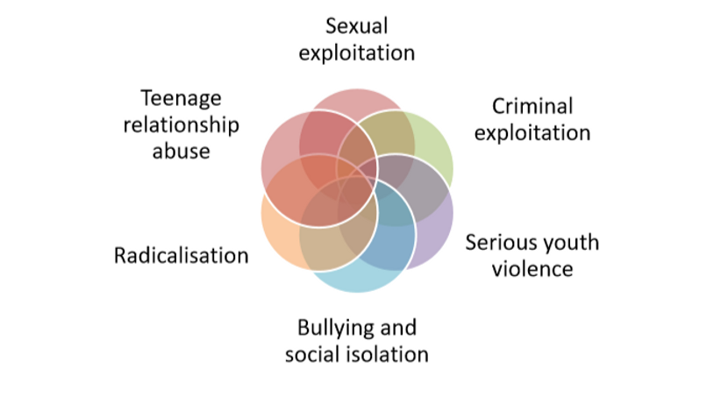

**Definition**

*‘Some children experience abuse and exploitation outside the home. This is often referred to as “extra-familial harm”. Harm can occur in a range of extra-familial contexts, including school and other educational settings, peer groups, or within community/public spaces, and/or online. Children may experience this type of harm from other children and/or from adults. Forms of extra-familial harm include exploitation by criminal and organised crime groups and individuals (such as county lines and financial exploitation), serious violence, modern slavery and trafficking, online harm, sexual exploitation, teenage relationship abuse, and the influences of extremism which could lead to radicalisation. Children of all ages can experience extra-familial harm.’* [***(Working Together 2023, Page 67).***](https://assets.publishing.service.gov.uk/media/65cb4349a7ded0000c79e4e1/Working_together_to_safeguard_children_2023_-_statutory_guidance.pdf)

.

**Approaches to Responding to Risk Outside of the Home**

**Building Safety Together**

To enhance the safety of children by addressing extra-familial harm in all forms we need to ensure that multi-agency practices focus on reducing risk and manage associated vulnerabilities that can worsen the wider risks.

As set out in the statutory guidance we must ensure that we collaborate with other local partnerships, such as Community Safety Partners, Children and Adults Safeguarding Boards, Health and Wellbeing Boards and Education, to develop and promote joint arrangements that consider these vulnerabilities.

These include, but are not limited to the following: *Child Sexual Exploitation (including harmful sexual behaviours), Criminal Exploitation, Children expressed to risk through gang involvement, county lines and serious youth violence, modern slavery and Trafficking, Radicalisation, children missing from home, care and education, domestic violence and abuse, Violence against women and girls, adolescent neglect, self-harm and suicide, substance misuse and special educational needs and disabilities (SEND).*

**To develop robust planning and approaches safeguarding partners and local decision makers may consider the following key recommended areas to support local planning and strategy development these may include:**

* **Understanding the problem and response**
* **Strong leadership**
* **Prevention and early intervention**
* **Protection and support**
* **Disruption and prosecution**

**Adopting an Evidence Led Approach**

The aim of this resource toolkit is to support partners working with children and communities to review, engage and strengthen their response to tackling harm that takes place outside of the home. The frameworks and activities can be used and adapted to inform local planning, safety planning with schools, youth sector and voluntary organisations.

To simplify use, resources are organised in thematic topics as detailed below. The toolkit will provide a brief description and direct links to signpost to the appropriate resource.

* **Building Safety with for Young People** *– working with adolescence, Effective Strategies and Developing Resilience*
* **Building Safety with Families and Communities** *– Co-production and building community guardianship with schools, Voluntary and community sector*
* **Guidance and Approaches to Responding to EFH and Risk Outside of the Home**  *–Systems Change, Statutory guidance, practice principles and evidence based approaches.*

To improve the effectiveness of interventions, practice should align with the following best practice guidance: Please consider the essential resources to serve as tools that can be used to begin your ‘building Safety’ Journey in order to respond to complex risk effectively.

[**Joining the Dots**](https://tce.researchinpractice.org.uk/joining-the-dots/) - Research in Practice - University of Bedfordshire, The Childrens Society – Practice Framework to respond to Exploitation and Extra Familial Harm.

[**Contextual Safeguarding Research Programme**](https://www.contextualsafeguarding.org.uk/) – Durham University – Evidenced based resource and approach to understanding, and responding to Childrens experiences of significant harm beyond their family and home.

[**That Difficult Age: Developing a more effective response to risk in adolescence**](https://www.researchinpractice.org.uk/media/1vhdzb3l/that_difficult_age_developing_a_more_effective_response_to_risk_in_adolescence_evidence_scope_2015.pdf)- Research in Practice, ADCS Leading Childrens, Services Elly Hanson and Dez Holmes

**Joining the Dots** *A framework to underpin and support ‘Creating Safety’ conversations and planning*

Joining the Dots is a framework, developed by Research in Practice and The Children Society is an open and free resource that can be accessed by local areas to support the development of cross-cutting approaches that are capable of responding to the complexity of tackling child exploitation and extra-familial harm. **Please follow the link to access the resource with a short animation video to find out more about how the framework can help you on your Creating Safety journey.**  [Joining the Dots - Tackling Child Exploitation (researchinpractice.org.uk)](https://tce.researchinpractice.org.uk/joining-the-dots/).

[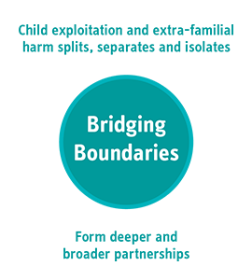](https://tce.researchinpractice.org.uk/joining-the-dots/bridging-boundaries/) [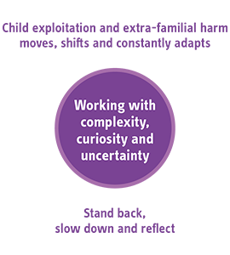](https://tce.researchinpractice.org.uk/joining-the-dots/working-with-uncertainty/)[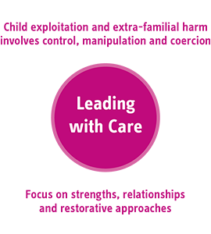](https://tce.researchinpractice.org.uk/joining-the-dots/leading-with-care/)

Links to attached guidance to support partnerships to think critically about how they can strengthen responses to tackling Child Exploitation and reducing Risk Outside of The Home.

* [TCE_Reflective-questions_V6.pdf (researchinpractice.org.uk)](https://tce.researchinpractice.org.uk/wp-content/uploads/2022/03/TCE_Reflective-questions_V6.pdf)
* [FINAL-Multi-agency-Practice-Principles-for-responding-to-child-exploitation-and-extrafamilial-harm-Designed-.pdf (researchinpractice.org.uk)](https://tce.researchinpractice.org.uk/wp-content/uploads/2023/03/FINAL-Multi-agency-Practice-Principles-for-responding-to-child-exploitation-and-extrafamilial-harm-Designed-.pdf)

**Building Safety with Young People** *a focus on working with children of adolescent ages*

Although risk outside of the home can impact children of all ages and professional curiosity should always be applied, vulnerability increases for children who are of adolescent age due to developmental changes.

Adolescence is a critical period of brain development, second only to infancy. This developmental phase starts with puberty and continues to the until the mid-20s, although the pace and changes varies for each individual. Most children begin to build upon their sense of identity and belonging, they experience an increase in independence meaning that they spend less time with protective adults. A brain development process begins back of the brain and moves to the front with the frontal part being the last to mature. This frontal region is crucial for planning, impulse control, and decision-making, explaining why teenagers can be forgetful, impulsive, and prone to making risky decisions.

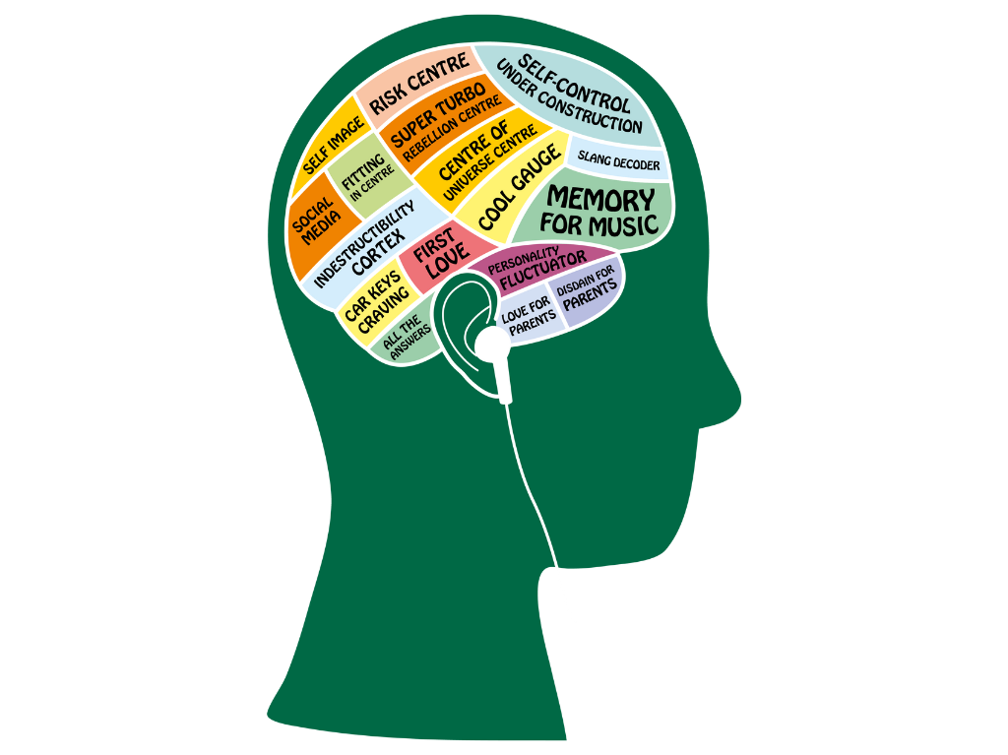

Some children experience the following **common behaviours during adolescence**

* Interpreting self-emotions, and those of others can often lead to misunderstandings in relationships.
* Being reactive, changes in mood and challenging boundaries
* Acting first and thinking later
* Peer influence is at peak, positive and negative influences, shaping social norms, values, and self-identity.

This can be a difficult period during a young persons life for caregivers and professionals to navigate. It is crucial that see adolescents as children first. It may be tempting to view/ treat them as mini-adults [(adultification bias)](https://www.justiceinspectorates.gov.uk/hmiprobation/wp-content/uploads/sites/5/2022/06/Academic-Insights-Adultification-bias-within-child-protection-and-safeguarding.pdf), especially to those who act older or are older. Remember they are still a child and we must respond with child and welfare led approaches.

There is much more to adolescent than their behaviour, recognising these developmental and behavioural changes aid with supporting them effectively.

**Taking an Adolescent Centred Approach**

Research in practice released the evidence scope, [*That Difficult Age: Developing a more effective response to risks in adolescence: (Hanson and Holmes 2014)*](https://www.researchinpractice.org.uk/children/publications/2014/november/that-difficult-age-developing-a-more-effective-response-to-risks-in-adolescence-evidence-scope-2014/) which looks at the serious and negative risk that face some children in the UK today with a focus on EFH. The paper explores key dimensions to adolescent risk and resilience

The paper promotes an adolescent centred approach to intervention, setting out the following practice principles:

* **Work with Adolescent Development –** *In particular perception, agency, aspiration and skill. For example, identify formation, friendships and attitudes to risk taking. This involves avoiding policies and practice that respond to adolescent behaviours and ensnare them.*
* ***Work with Young People as Assets and Resources***
* ***Promote Supportive Relationships –*** *Between young people, their families and peers. (Where Possible)*
* ***Take a Holistic Approach –*** *to young people and the risks they take*
* ***Ensure Services are Accessible and Advertised –*** *For example, services should incorporate self-referral mechanisms, social marketing and assertive outreach in hard to reach groups*
* ***Equip and Support the Workforce –*** *Through high quality learning opportunities and regular supportive supervision*

**Building Safety with Young People** *in Contexts*

Children of adolescent age require the systems that support them to think differently about how they can keep them safe from harm that happens place beyond their doorsteps. It is important that we include their voice to inform the safety planning and intervention. It is important that we include ways to enable participation to begin to help us to understand the world and experiences through their eyes.

The Durham University Contextual Safeguarding programme offers a number of evidenced based resources within the [Scale Up Toolkit](https://www.contextualsafeguarding.org.uk/toolkits/scale-up-toolkit/) that help to engage young people to gain a good understanding of what is happening in various contexts such as spaces they spend time, with peers or online spaces. [The Space, Safety, and Young People Survey](https://www.contextualsafeguarding.org.uk/resources/toolkit-overview/tool-space-safety-and-young-people-survey/) can be used to with young people to gather general views about safety in different contexts. This tool should be used with the additional resources from the scale up toolkit.

**The toolkit features resources can help anyone looking to build safety working with**

[Peers | Contextual Safeguarding](https://www.contextualsafeguarding.org.uk/toolkits/scale-up-toolkit/peers/) *Understanding peer relationships should be central to all safeguarding efforts for young people experiencing extra-familial harm. We need to learn how to see the unique strengths and potential that there is in each peer group, and working*with*- not against - these.*

[Schools | Contextual Safeguarding](https://www.contextualsafeguarding.org.uk/toolkits/scale-up-toolkit/schools/) – *Schools play a significant role in a child’s development, offering a space for independence, socialization, and learning. However, students also report experiencing harm from peers within these environments. Addressing harm in schools involves looking beyond individuals to consider the cultures, systems and structures that can either protect or harm students. Schools, with their distinct cultures and large gatherings of young people, have substantial potential for positive change*

[Locations | Contextual Safeguarding](https://www.contextualsafeguarding.org.uk/resources/toolkit-overview/toolkit-locations/) *- Community locations such as parks, shopping centres, housing estates, or shops, are also important in safeguarding young people. Traditional safeguarding systems focus on homes, but contextual safeguarding expands this to include spaces where people spend time. When concerns arise about harm in specific location, it is essential to first understand the dynamics behind harm occurring there. Online spaces should also be considered when thinking about spaces where children spend time.*

**Supporting conversations** *with young people and appropriate language*

When talking about young people language matters. It can be the difference between a young person getting the support they need or it could put them at further risk. Changing our language can make a significant difference to how we engage and support young people but also to our mindset and decision making. The Durham University [Scale-Up toolkit engaging young people and parents](https://www.contextualsafeguarding.org.uk/toolkits/scale-up-toolkit/engaging-young-people-and-parents/) resource includes guidance for [supporting conversations with young people](https://www.contextualsafeguarding.org.uk/resources/toolkit-overview/tool-language-activity-sheet/) which is made up of some short activities where young people can identify the kind of language they feel is appropriate to use when working them.

We should not use language that implies that a child Is responsible in any way for abuse and crime that they are subjected to. It can reinforce harmful relationships, and create barriers when attempting to engage young people as it can lead to them thinking that they will not be believed or supported.

**Victim Blaming**

Victim blaming language is an action that implies that a person is partially or wholly responsible for their abuse. The Children’s society have developed [Language Guidance](https://www.childrenssociety.org.uk/information/professionals/resources/child-exploitation-language-guide#:~:text=DON%27T%20use%20language%20implying,when%20trying%20to%20control%20them.) for using appropriate language when discussing children and their experiences.

The UK council for internet safety has also developed guidance for [challenging victim blaming language and behaviours when dealing with the online experiences of children and young people.](https://www.gov.uk/government/publications/challenging-victim-blaming-language-and-behaviours-when-dealing-with-the-online-experiences-of-children-and-young-people)

*Please see the short video, focused and powerful video resource from Waltham Forest Council that can be used to help professionals and others understand the impact of victim blaming language.*

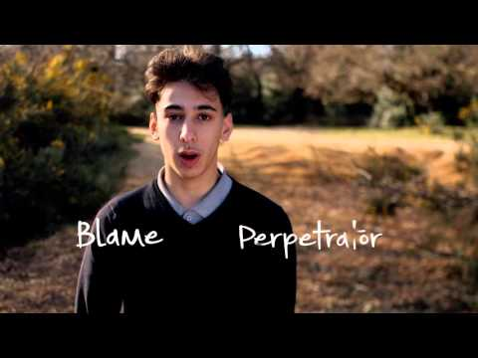

**Support and Mentoring** *for young people*

Not all children and young people will find it easy to talk to the trusted people in their lives, this extends to professionals who may work together to keep them safe from harm. A barrier to this could be that they are fearful of being in trouble, judged or they feel that decisions are made for them that they feel unhappy about.

Sometimes it can be easier for children and young people to speak to people who are not making decisions for them. Support and mentoring will not only offer a safe space to talk things through but also creates an important space to link children in to help them understand the harm that is taking place in ways that they can understand.

The following organisations can offer face to face support

[**Independent Child Trafficking Guardianship Service**](https://www.barnardos.org.uk/get-support/services/national-counter-trafficking-centre-including-independent-child-trafficking) **– Supported by Barnardos, specialist support for children who have been trafficked**

[**County Lines Support and Rescue**](https://www.catch-22.org.uk/find-services/county-lines-support-and-rescue/) **– from** [**Catch 22**](https://www.catch-22.org.uk/) **One to One support to young people and their families. Offering an out of hours service at reachable/ teachable moments**

[**St Giles**](https://www.stgilestrust.org.uk/) **– Work with children who are experiencing adverse circumstances such as having a parent in prison. Supporting young people with community based support working in hospitals and local communities to find employment, resettle prison leavers, safely exit gangs, criminal and sexual exploitation. Prevention and intervention, support for young people though the** [**SOS+**](https://www.stgilestrust.org.uk/sos/) **service which can offer school visits, group work sessions, 1 to 1 mentoring.**

[**Redthread**](https://www.redthread.org.uk/) **– Youth work charity working alongside children and young people at moments of crisis. Being there for them in hospitals and other health settings.**

**Building Resilience** *key resources for young people*

Although young people will require intervention and support to keep them safe we can also help them to build resilience to help reduce risks and harm, and manage personal wellbeing to develop copying mechanisms. A powerful way to build resilience with young people is by giving them tools that can help them to identify and activate their strengths.

**The following key resources can be shared with young people and their families to help build resilience**

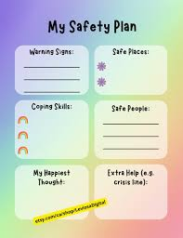

* [**Childline**](https://www.childline.org.uk/info-advice/) **-** 24/7 anonymous service that children can accessONLINE, ON THE PHONE, ANYTIME. Information and guidance to help guide decisions that are right for young people, 1 to 1 support, live chat, counselling services, message boards, wellbeing toolbox and free personal account.
* [**Kooth**](https://www.kooth.com/) **–** Free online anonymous place, for young people to find support and counselling. A number of features such if yp’s are looking for advice, magazine written by young people, discussion boards, smart personal goal setting, personal journal, chat and messenger.
* **Report Remove Tool** [**Childline**](https://www.childline.org.uk/info-advice/bullying-abuse-safety/online-mobile-safety/report-remove/?gclsrc=aw.ds&gad_source=1&gclid=Cj0KCQjwsuSzBhCLARIsAIcdLm5oQ_u_XG4ZoEJEKHTqEzWJBXS9y-gm_JxtrIKKANWc-C8g2aEX7t4aAs88EALw_wcB&gclsrc=aw.ds) **–** Report Remove is here to help young people under 18 in the UK to confidentially report sexual images and videos of themselves and remove them.
* **[St Johns Ambulance, Young Responders](https://www.sja.org.uk/get-involved/young-people/young-responders-home/)** – Designed for young people delivering scenario-based, hands-on first aid sessions. Street First Aids Sessions, responding to bleeds, alcohols and drug intoxication, CPR. Sessions can be delivered to children in schools, communities and youth group organisation
* [**Fearless**](https://crimestoppers-uk.org/fearless) **–** Anonymous Crime reporting app and helpline, young people can access Information and advice about crime and criminality
* [**Youth Endowment Fund: YEF Toolkit**](https://youthendowmentfund.org.uk/yef-toolkit-what-works-to-prevent-youth-violence/) – An overview of existing research on approaches to preventing harm outside of the home
* **West Midlands Violence Reduction Partnership** – Primary prevention programme. Round Midnight Virtual Reality Choices and Decisions sessions, Mentors in Violence Programme/ Change Makers, My Tomorrow youth movement programme.

**Building Safety with Families and Supportive Networks**

Traditionally, Childrens safeguarding has focussed on harm that takes place within the family however, for some young people the risk of significant harm doesn’t come from within their families but in the community. Extra familial harm, such as child exploitation, can undermine parent-child relationships and blaming families in such circumstances can extenuate the harm the child faces. Sometimes professionals can be overly focussed to the family background as being the root of the cause of the abuse, potentially disempowering family members who are trying to protect their child.

An approach to keeping young people safe from harm outside of the home is known as ‘contextual safeguarding’. Parents and carers may have little understanding or influence over the contexts their children may spend time in, it is important that we work with a child’s network to offer safer environments and networks. Families and networks can play an extremely important role in protecting their children to build resilience and safety together.

**Relational Approach**

[The relational safeguarding model](https://ivisontrust.org.uk/wp-content/uploads/2013/11/Relational-Safeguarding-Model-FINAL-PRINTED-May-2014.pdf), aligned with the recommendations of the [Munro Review (2011](https://www.gov.uk/government/publications/munro-review-of-child-protection-final-report-a-child-centred-system)), assumes parents are willing and capable of protecting their child, emphasizing the important of forming relationships with children, families and their community networks.

Relational safeguarding can support professionals and planners to work in partnership with parents, carers, families and communities, by taking this approach we can facilitate and supporting them, in order to maximise the ability and capacity of statutory agencies’ and families’ to safeguard children at risk of EFH.

***Relational practice focusses on the following:***

**• Maximising the capacity of parents and carers to safeguard their children and contribute to the prevention of abuse and the disruption and conviction of perpetrators.**

**• Early intervention and prevention.**

**• Enabling family involvement in safeguarding processes around the child, including decision making.**

**• Ensuring the safety and wellbeing of the family in recognition of the impact of CSE.**

**• Balancing the child’s identity as both an individual and as part of a family unit**

**Building Resilience** *key resources for parents and support networks*

**Importance of supportive networks**

For some children, young people and their families who experience exploitation or increased risk outside of the home may require support and intervention. However, in most cases safety can start at home with parents, carers, extended family members and supportive networks. Awareness and understanding of risks by supportive network make them key safeguarding partners. Supportive networks help manage they can be key safeguarding partners who can help children to manage some risks, reduce harm and enjoy positive experiences.

**Safety Conversations** *building safety with children*

**Discussing Positive Risk**

**• What is Risk:** Talk about potential risks young people may face when exploring independence

* **Encourage Input:** Ask young people for their input on how they perceive risk and social rules

**Communication and identifying safe contacts**

* **Who to Contact:** Discuss when, how, and who to contact when worried (can we signpost to organisations like ChildLine/ Fearless)
* **Safe Network:** Identify and discuss who their safe network is (trusted friends, family, neighbours, sports coaches, mentors, community members).

**Building Confidence and Problem Solving**

* **Focus on Strengths:** Highlights strengths and aspirations to build confidence and provide positive experiences.
* **Scenario Planning:** Discuss specific scenarios where risks may increase and problem-solve together on how to exit harmful contexts.

**Safety Codes and Areas**

* **Code Word:** Develop a code word young people can use with trusted people to signal they feel unsafe
* **Safe and Unsafe Areas:** Talk about safe and unsafe areas and how to exit from certain situations or spaces.

**Building Safety Together**

* **Discuss Boundaries:** Includes young people in conversations about boundaries, such as curfews.
* **Flexibility with Safety Measures:** Consider flexibility in boundaries if phone locations are shared or if there is a trusted friend to contact if they become unreachable.

**Safety Planning** *Building Online Safety*

The internet is an integral part of young people’s lives, providing opportunities for learning, socializing, and entertainment. However, it also exposes them to risks such as cyberbullying, inappropriate content and online predators. For some online spaces can become overwhelming, trying to keep up with friends and the pressure can mount.

Ensuring internet safety is crucial to protect young people from these dangers and to help them navigate the digital world responsibly. Noticing how children and young people can be affected by being online is the first step in helping them manage social situations and wellbeing. There are several things you can do to support a child, including using specific apps and checking app settings

**You can:**

* **Discuss online risks**
* **Manage the content children see**
* **Ensure the interactions they have are suitable**
* **Manage how long they’re online, in balance with other activities**

Understanding online safety is trick for all ages. The following resources can support families and supportive networks to think about their role in keeping children and young people safe online.

* [NSPCC](https://www.nspcc.org.uk/keeping-children-safe/online-safety/?_gl=1*1cph47j*_up*MQ..&gclid=Cj0KCQjwsuSzBhCLARIsAIcdLm53SW6Gn9CeC-XQxD8FWy0U_DzdyVGOTDvRw4yskClzf348slzWZSMaAkxZEALw_wcB&gclsrc=aw.ds) a designated resource featuring online safety advice. Advice on how to [Teaching Your Child about Internet & Online Safety | NSPCC](https://www.nspcc.org.uk/keeping-children-safe/online-safety/talking-child-online-safety/?_gl=1*gnbt84*_up*MQ..&gclid=Cj0KCQjwsuSzBhCLARIsAIcdLm53SW6Gn9CeC-XQxD8FWy0U_DzdyVGOTDvRw4yskClzf348slzWZSMaAkxZEALw_wcB&gclsrc=aw.ds) and get support, [‘Techosaurus’](https://www.nspcc.org.uk/keeping-children-safe/support-for-parents/techosaurus/?_gl=1*1sp670d*_up*MQ..&gclid=Cj0KCQjwsuSzBhCLARIsAIcdLm53SW6Gn9CeC-XQxD8FWy0U_DzdyVGOTDvRw4yskClzf348slzWZSMaAkxZEALw_wcB&gclsrc=aw.ds) to help with those first conversations about online safety, [online wellbeing](https://www.nspcc.org.uk/keeping-children-safe/online-safety/online-wellbeing/?_gl=1*gnbt84*_up*MQ..&gclid=Cj0KCQjwsuSzBhCLARIsAIcdLm53SW6Gn9CeC-XQxD8FWy0U_DzdyVGOTDvRw4yskClzf348slzWZSMaAkxZEALw_wcB&gclsrc=aw.ds), [TRUST toolkit](https://www.vodafone.co.uk/help-and-information/nspcc-phone-safety-toolkit) supporting parents who are considering getting their first phone of device. BLOG on the latest online safety tips.
* [Internet Matters](https://www.internetmatters.org/issues/online-reputation/protect-your-child/) resource to help families and support networks children take control of what they share online an learn how to build a positive online reputation that will support their future education or career aspirations.
* [CEOP](https://www.ceop.police.uk/Safety-Centre/) Child Exploitation and Online Protection. Safe and secure reporting of online sexual abuse, reporting mechanisms and online child protection advisors.

**Other Useful Resources**

* The [Ivison Trust](https://ivisontrust.org.uk/for-parents/) recognises the lifelong commitment parents have for their child and a responsibility to keep them safe. Parents, carers and trusted adults can access support and guidance working with parents to tackle child exploitation. The trust offers FREE telephone support from their national parent support team, FREE learning events, webinars and e-learning that can be shared with parents to support understanding and how to respond.
* [Crime Stoppers](https://crimestoppers-uk.org/?gad_source=1&gclid=CjwKCAjw1emzBhB8EiwAHwZZxS-dLLBcArKEKVhBkMBawBwLJhVjToVS9wEMH0hABa12Bl7gMza_NhoCCMsQAvD_BwE) Keeping families and Communities Safe in the UK. Report Crime Completely and Anonymously, By Phone, Or Online
* [Listen Up, Speak Up](https://www.nspcc.org.uk/support-us/listen-up-speak-up/) supporting the public to play their part in keeping children safe. Offering resources on how to speak up for children this includes: 10 Minute Digital training, FREE face to face local workshops for the public to attend and a marketing campaign.

**NSPCC Listen up, speak up will show you:**

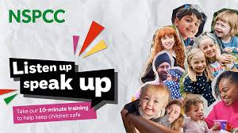

* **Some Signs that Children might be at risk, and steps to take**
* **How to approach difficult conversation to help keep children safe**
* **Who you can contact if your ever concerned about a child to or their family**

The [Support & advice for parents | NSPCC](https://www.nspcc.org.uk/keeping-children-safe/support-for-parents/) offers additional support and resources that provide advice on a number of issues from Early Parenting advice, managing family life, Friends and relationships, and staying safe online. These resources can be accessed in a number of ways. The NSPCC helpline is also a space where families and trusted networks can seek help, advice and support when they have concerns for a child. [help@nspcc.org.uk](mailto:help@nspcc.org.uk) **Tel: 0808 800 500**

**Building Safety in the Community -** *Schools, Voluntary and Community Sector*

**Contextual Safeguarding** - Responding to harm beyond the front doors

Contextual safeguarding is a welfare led approach to understanding and responding to Childrens and young person’s experiences of significant harm beyond their families. It recognises that the relationship children form in neighbourhoods, schools and online can feature violence and abuse. Contextual safeguarding is a child welfare and rights-based approach that recognises that parents have little influence over these contexts, and harm that takes place outside of the home can often undermine child-parent relationships.

**Please use the links to the short animation videos about contextual safeguarding and the supporting theory behind it.**

[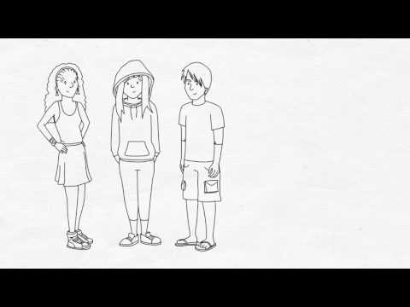](https://www.youtube.com/watch?v=V0lE-XENewM) [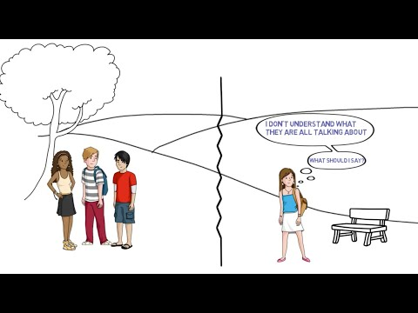](https://www.youtube.com/watch?v=1yuQWNO1mEM)

What is contextual Safeguarding? Social Theory and Contextual Safeguarding

Traditional safeguarding agencies, typically focussed on addressing harm and abuse that takes place within the family, may lack the necessary tools and resources to effectively respond to extra-familial harm that often may occur in settings (Contexts) like schools, neighbourhoods and among peer groups. Professionals and communities that interact with our children on a daily basis often face challenges in providing adequate support. This difficulty is compounded when young people do not meet the thresholds for support via the safeguarding agencies, leading to complex and limited support structure to respond to harm outside of the home.

**Contextual Safeguarding Toolkits and Resources** – *Durham University*

To address harm that takes place beyond the home the contextual safeguarding research indicates that whole-systems approaches need to be taken to prevent and respond to children and affected. This requires developing ways of building safety within communities, beyond solely making referrals to safeguarding agencies.

[The Scale-Up Toolkit](https://www.contextualsafeguarding.org.uk/toolkits/scale-up-toolkit/) provides resources needed to start thinking about creating a Contextual Safeguarding System

[Beyond Referrals](https://www.contextualsafeguarding.org.uk/toolkits/beyond-referrals/) was a four year project funded by the Esmee Fairbairn Foundation. The project worked with schools and voluntary and community sector organisations to help them respond to extra-familial harm. The [Beyond Referrals](https://www.contextualsafeguarding.org.uk/toolkits/beyond-referrals/) toolkit provides for schools and voluntary sector organisations that are concerned about assessing their response to extra-familial harm such as child sexual and criminal exploitation, serious youth violence, peer on peer abuse and bullying.

**There were four different parts to the Beyond Referrals project:**

[**Harmful sexual behaviour in schools**](https://www.contextualsafeguarding.org.uk/resources/toolkit-overview/beyond-referrals-harmful-sexual-behaviour/)Worked with schools to address harmful sexual behaviour in schools.

[**Multi-agency responses**](https://www.contextualsafeguarding.org.uk/resources/toolkit-overview/beyond-referrals-multi-agency/)Worked with multi-agency partners to consider how they respond to harmful sexual behaviour in schools

[**Extra-familial harm in schools**](https://www.contextualsafeguarding.org.uk/resources/toolkit-overview/beyond-referrals-extra-familial-harm/)Expanded the harmful sexual behaviour tool for use with all forms of extra-familial harm.

[**Towards Safety**](https://www.contextualsafeguarding.org.uk/resources/toolkit-overview/towards-safety/)Worked with voluntary and community sector partners to create the Towards Safety tool for VCS organisations.

**The Principles of Contextual Safeguarding:**

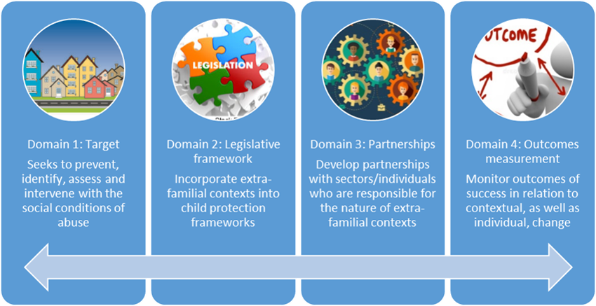

**Building Safety in Schools** *strengthening EFH responses in schools*

Education settings provide a space for children to grow, think and feel safe. However, education settings can be a space where EFH takes place. Schools, colleges and alternative provisions are uniquely positioned to keep children safe from EFH. Of course, there are many other agencies involved these include local authorities, Childrens social care, youth justice services, the police and others. But education settings also have a crucial role to play.

[**Beyond Referrals Toolkit for Schools**](https://www.contextualsafeguarding.org.uk/resources/toolkit-overview/beyond-referrals-extra-familial-harm/)Levers for addressing ‘Extra Familial’ harm in schoolsContextual safeguarding promotes an approach that targets the social conditions where harm is taking place. This toolkit is designed to be used to support [**‘contextual safety’**](https://www.contextualsafeguarding.org.uk/about-us/), **that is, safety in your school/ college context.** The harms young people may face outside of their homes are constantly evolving, and no school will get everything right all the time however, it is crucial that we develop and review our response to reduce harm that takes place in spaces where children spend their time.

The toolkit should be used to identify what you are doing well to mitigate against the harm risks in your school or college, and, importantly, to identify areas for development and improvement. Each category represents a ‘lever’ for preventing and addressing ‘extra-familial harm’ in school settings. Each leaver has various components against which a school can assess itself and develop a plan of action as a result**There are five categories of self-assessment:**

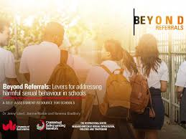

**Systems and Structures**

**Prevention**

**Identification**

**Response and Intervention**

**School Culture**

The [**Beyond Referrals Toolkit for Schools**](https://www.contextualsafeguarding.org.uk/resources/toolkit-overview/beyond-referrals-extra-familial-harm/) includes the following resources to support education settings on their journey to ‘Build Safety’. This includes the following to support individual schools to think about how they can extend their response to EFH.

* **Self-Audit Toolkit -** *A traffic light tool that is designed to support schools to audit their ability to effectively prevent and respond to ‘extra-familial harm. It is not a static document, rather is should be used as process. The tool is designed to support ‘contextual safety’, this is safety in your school context. (See example on next page)*
* **Guidance Video** *Please use the link to the short guidance video Beyond Referrals: Levers for addressing ‘extra familial harm’ in schools.*
* **Behaviour Log Review** *Guidance method that can help schools to complete the beyond referrals audit*
* **Hotspot Mapping Tool** *In order to create safety we must understand what the social rules are for young people to intervene with the space. This tool can be used with young people to inform the referrals audit and polices and procedures review*
* **Policies and Procedures Review** *This guidance outlines one method that can help a school complete the beyond referrals audit- reviewing school policies and procedures*

Links to attached guidance to support schools and stakeholder partnerships to think critically about how they can strengthen responses to tackling EFH and risk outside of the home.

[Beyond Referrals: Levers for addressing 'extra familial harm' in schools on Vimeo](https://player.vimeo.com/video/586734382)

[Beyond Referrals: extra-familial harm | Contextual Safeguarding](https://www.contextualsafeguarding.org.uk/resources/toolkit-overview/beyond-referrals-extra-familial-harm/)

The [Beyond Referrals Traffic Light Tool](https://www.contextualsafeguarding.org.uk/media/tvflfizh/csn_beyondreferrals_efh_toolkit_artwork_v2.pdf) can be used to by schools who are concerned about assessing their response to EFH in schools such as bullying, peer on peer abuse, child sexual and criminal exploitation and serious youth violence. This guidance can be used with the additional supporting tools which can be accessed via the toolkit links.

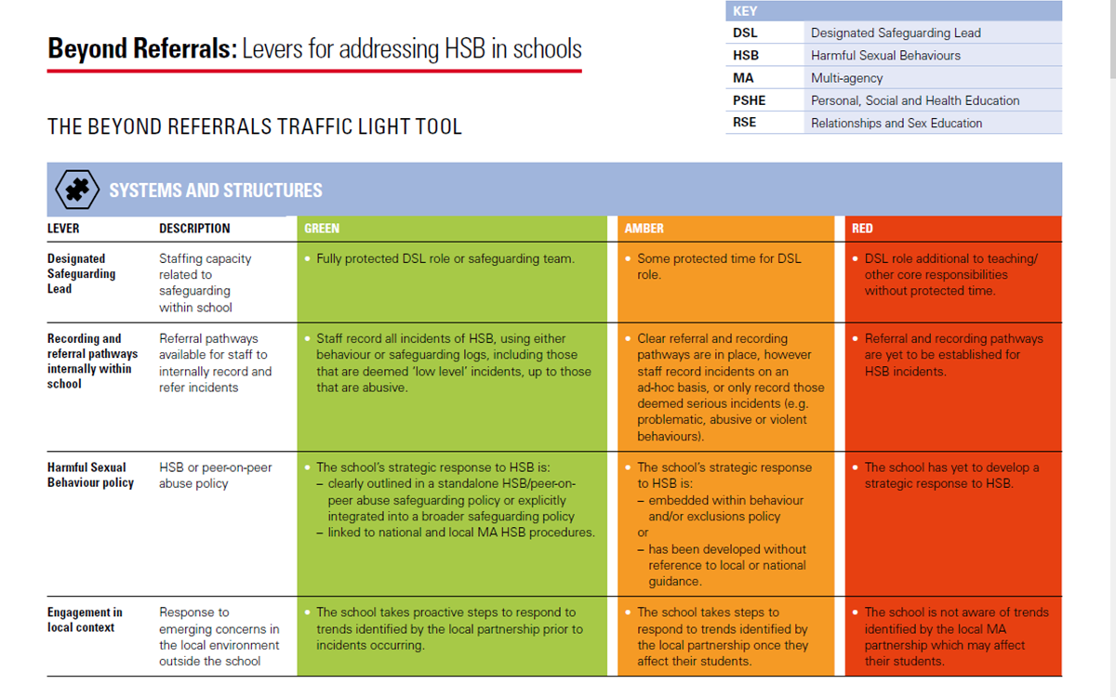

**Supporting the Voluntary and Community Sector (VCS)** Levers for safeguarding in voluntary and community sector youth organisations

When young people spend time in voluntary and community sector youth organisations they do so voluntarily. These spaces offer young people opportunities to socialise with each other, learn and develop in community settings. Young people may also be exposed to a range of interpersonal and extra-familial harms within these contexts and the local neighbourhood spaces that surround them. When such harm occurs VCS organisations can play a role in safeguarding the welfare of the young people, groups and environments they choose to spend their time in. This safeguarding role can extend beyond referring young people into statutory agencies for support.

The following resources can help to support youth-facing VCS Organisations who are interested in building safety within their organisation.

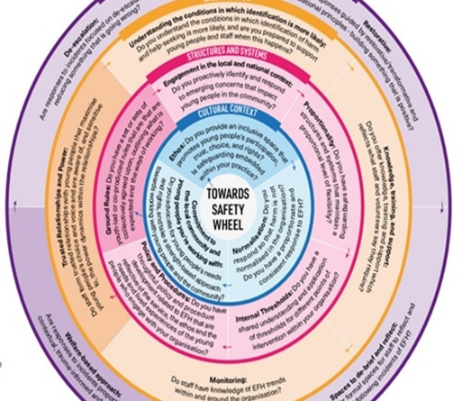**Recommended resources and toolkits:**

[**Beyond Referrals**](https://www.contextualsafeguarding.org.uk/resources/toolkit-overview/towards-safety/)

[**Towards Safety Self-Assessment Resource and Guidance**](https://www.contextualsafeguarding.org.uk/resources/toolkit-overview/towards-safety/)

Interactive resource and guidance on the towards safety

Wheel, supporting VCS organisations to identify things that

you are doing already to create safe contexts, as well as

any barriers to this.

[**Towards Safety Wheel**](https://www.contextualsafeguarding.org.uk/resources/toolkit-overview/towards-safety/)can be used to support VCS organisations

To identify factors that build safety for young people.

**NSPCC** Resources to support safeguarding in voluntary and community groups

[**NSPCC Resource and guidance**](https://learning.nspcc.org.uk/safeguarding-child-protection/voluntary-community-groups) that includes recommendations when developing safeguarding standards, introductory guide to setting up safeguarding and child protection measures, self-assessment tool, developing campaigns.

**Building Systems** *that Respond to Risk Outside of the Home*

**The Scale-Up Toolkit**

A collection of resources from Durham University, to help you to start thinking about creating safety by building Contextual Safeguarding Systems. What is a contextual safeguarding system? How do you provide contextual approaches to children that experience harm outside of the homes? Where do you start? The scale up toolkit provides everything you need to take you through the process of creating contextual approaches to respond to harm outside of the home.

**The Scale-Up Toolkit is designed to offer resources and strategies that support the following**

[System Change](https://www.contextualsafeguarding.org.uk/toolkits/scale-up-toolkit/system-change/) What does a contextual safeguarding system look like?

[Engaging Young People](https://www.contextualsafeguarding.org.uk/toolkits/scale-up-toolkit/engaging-young-people-and-parents/) How do you engage young people about systems change?

[Working with Individual Young People](https://www.contextualsafeguarding.org.uk/toolkits/scale-up-toolkit/individual-young-people/) How can you bring contexts in to individual and family social work?

[Strengthening Multi-Agency Practice](https://www.contextualsafeguarding.org.uk/toolkits/scale-up-toolkit/multi-agency-panels/) Some key things to consider when developing panels to address EFH

Supporting Planning and Interventions in Contexts such as [Peers,](https://www.contextualsafeguarding.org.uk/toolkits/scale-up-toolkit/peers/) [Schools](https://www.contextualsafeguarding.org.uk/toolkits/scale-up-toolkit/schools/) and [Locations](https://www.contextualsafeguarding.org.uk/toolkits/scale-up-toolkit/schools/)

[Responses and Outcomes](https://www.contextualsafeguarding.org.uk/toolkits/scale-up-toolkit/responses-and-outcomes/) How do we respond to the social conditions that facilitate extra-familial harm?

**Raising Awareness for professionals across Multi-Agency Partnerships** Awareness Sessions

**Local Safeguarding Children Boards** (LSCBs)

The task of local safeguarding boards is to safeguard and promote the welfare of children and young people in their area. The scope of the safeguarding task for LSCBs covers broad areas of activity which look to identify and prevent maltreatment or impairment to health and development. Pro-active work, which targets particular groups of vulnerable children and young people. Responsive work to protect children who are suffering or at risk of harm. Each LSCB will offer a menu of training and awareness sessions that will be relevant to individual area, and can be accessed across all partnerships to support ongoing professional learning and development.

**West Midlands Violence Reduction Partnership** Primary Prevention Offer

[The West Midlands VRP](https://westmidlands-vrp.org/about/) primary prevention offer, focusses on evidenced based primary, secondary and tertiary, school-based interventions that support children, young people and professionals to prevent and respond to violence that is happening in their area.

[The National Counter Trafficking Centre](https://nctc.org.uk/) which is hosted by Barnardos offers free awareness raising sessions aimed at increasing professionals knowledge on outstanding issues relating to child trafficking, exploitation and modern slavery. All sessions are free and run monthly online. Subjects cover ICTG The

[The NWG Network](https://nwgnetwork.org/events/) host a number of event throughout the year to help educate, offer guidance and signpost to share knowledge of issues people and organisations face around the exploitation of children and adults. Please note a some sessions are costed others, and practice forums are offered at no cost.

[NSPCC elearning: and online courses](https://learning.nspcc.org.uk/training/our-elearning-courses)a full range of training and course, designed to support in learning about all aspects of child protection and safeguarding.

**Relevant Statutory Guidance and Local Procedures**

[*Working Together to Safeguard Children (2023)*](https://www.gov.uk/government/publications/working-together-to-safeguard-children--2)In December 2023, The Department of Education (DfE) published a new edition of its statutory guidance Working together to safeguard children, replacing the previous edition of 2018. The 2018 version, for the first time, included ‘extra-familial harm’ (EFH) as a category of harm that child protection should be equipped to identify and respond to.

[*Regional Child Protection Procedures for West Midlands*](https://westmidlands.procedures.org.uk/page/contents)West Midlands combined local multi-agency safeguarding procedures. Each local area’s multi-agency safeguarding arrangements are led by the statutory safeguarding partners/organisations: local authorities, clinical commissioning groups and police.

[*The Children Act 1989*](https://www.legislation.gov.uk/ukpga/1989/41/contents)The Children Act 1989 introduced significant harm as the threshold that justifies compulsory intervention in family life in the best interests of children. Physical Abuse, Sexual Abuse, Emotional Abuse and Neglect are all categories of significant harm and can feature in within both intra-familial and extra-familial harm.

[*The Serious Violence Duty 2022*](https://www.gov.uk/government/publications/serious-violence-duty)Makes councils and local services work together to share information and target interventions to prevent and reduce serious violence focussing on prevention and early intervention informed by evidence. The duty responds to a broad range of violent crimes including homicide, serious youth violence, exploitation and violence against women and girls